**TechTrek 2022 Challenge**

**Statement**

22nd July 2022

**Introduction**

With the borders opening once again, the travel industry is starting to pick up. As a bank that aims to create banking that’s within our customers’ reach, DBS needs to be ready to cater to our customers’ jet setting adventures. Keeping up with the cashless trend, an e-wallet will be the optimal solution to keep our customers’ savings safe while still providing convenience and quick access to money. This would enable them to store, convert, and send currencies on the fly.

**Challenge Statement**

Your task is to create a simplified full-stack multi-currency account which allows customers to access and perform transactions with their currency wallets. This could lessen the workload of our bank staff and allows customers to convert currencies wherever, at their convenience. This **must** be a **web application**.

**\***For every Frontend task, there will be a matching Backend task as indicated by the numbering. E.g.

|  |  |
| --- | --- |
| **Basic Requirements (Frontend)** | **Basic Requirements (Backend)** |
| User must be able to login **[1]** | Server must be able to authenticate a user's identity **[1]** |

**Basic Application Requirements (Frontend):**

* You must render a login page
  + User must be able to login **[1]**
* You must render a dashboard
  + Display a live update of exchange rates **[2]**
  + Users must be able to view all wallets under current user **[3]**
* Users must be able to:
  + Create transactions considering the debit and credit currencies **[4]**
    - Select currencies for the transaction.
    - Values should be converted on the UI instantly.
  + View all currency-wallets' data (I.e., currency specific balance). **[5]**
  + Remove wallet when user wants to close account. **[6]**

**Basic Application Requirements (Backend):**

* You must set up a valid authentication API
  + Server must be able to authenticate a user's identity **[1]**
* You must set up the respective API with the following functionalities:
  + Return a list of exchange rates from the ***Exchange Rate*** table **[2]**
  + Return a list of currency-wallets of a user from the ***Currency*** table **[3]**
  + Insert transactions created from frontend into ***Transaction*** table **[4]**
  + Return a list of all wallet details from the ***Wallet*** table **[5]**
  + Delete currency-wallets removed from frontend into ***Wallet*** and ***Currency*** table **[6]**

**Basic Application Requirements (Integrate):**

* Integration is a crucial requirement for this hackathon. The front end and back end should be ***integrated*** seamlessly.

**Advanced Requirements (Optional, in any order, but good to have):**

* Data visualization through charts and graph
* Include JSON Web Tokens in your authentication
* Features that enhance the user journey

**Optional Technical Depth (showcase your skill set):**

* AWS/GCP to deploy your application to the cloud

**Data provided**

You will be given:

* Data in *JSON* and *SQL* format
  + The entries provided are not exhaustive and you can add more to suit the needs of your application
  + Entity Relationship Diagram (ERD). The following ER diagram is provided as a reference. We have provided datasets for ***User, Exchange Rate, Wallet, Currency*** and ***Transaction*** entities.
  + The ***Wallet, Currency*** and ***Transaction*** tables provided can be used to show how the CRUD is being implemented. These tables are part of the requirements **[2-6]**.You are free to add new attributes to match any new features you wish to introduce; teams **MAY** make changes so long as tasks requirements are met.

**ERD Diagram**

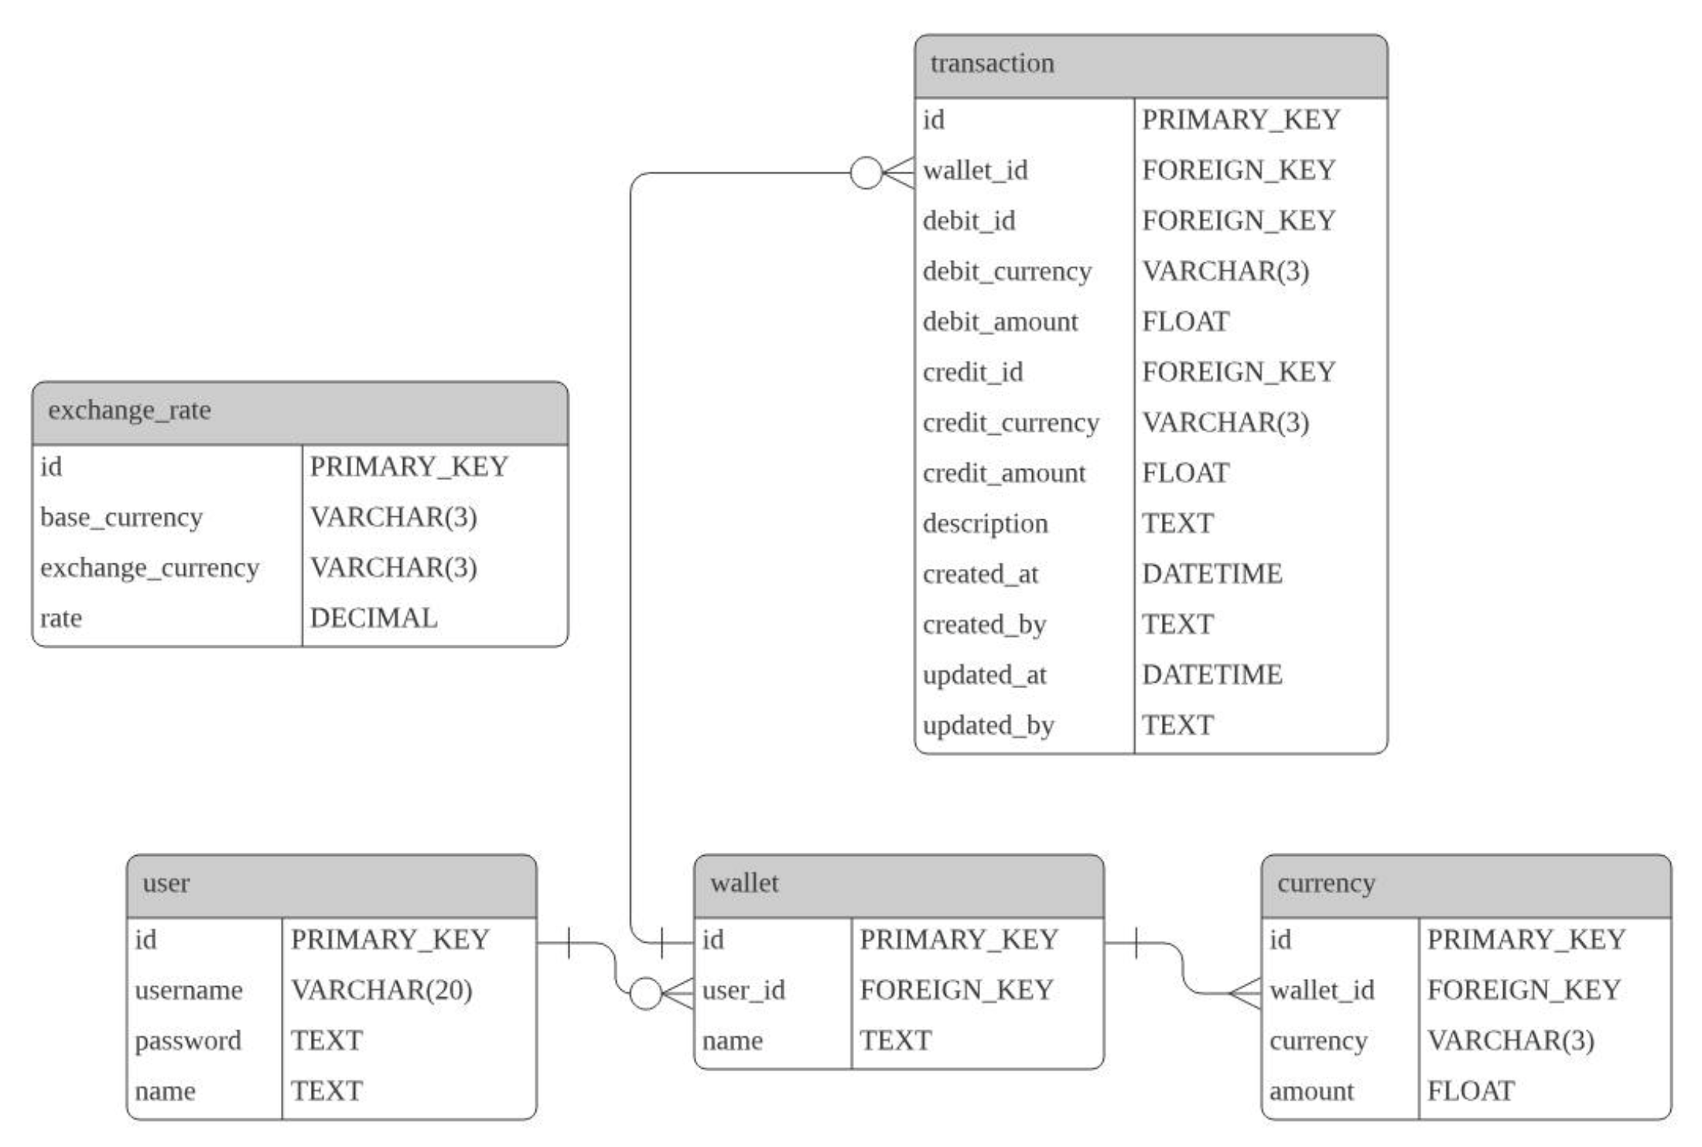

**Database Example**

**Exchange Rate Table**

|  |  |  |  |
| --- | --- | --- | --- |
| Id | Base Currency | Exchange Currency | Rate |
| 1 | USD | SGD | 1.4077 |

**User Table**

|  |  |  |  |
| --- | --- | --- | --- |
| Id | Username | Password | Name |
| 1 | user101 | 123456 | Jacky |

**Wallet Table**

|  |  |  |
| --- | --- | --- |
| Id | User Id | Name |
| 1 | 1 | Multi-Currency Account |

**Currency Table**

|  |  |  |  |
| --- | --- | --- | --- |
| Id | Wallet Id | Currency | Amount |
| 1 | 1 | USD | 1023.56 |

**Transaction Table**

|  |  |
| --- | --- |
| Id | 1 |
| Wallet Id | 4 |
| Debit Id | 21 |
| Debit Currency | SGD |
| Debit Amount | 42231.00 |
| Credit Id | 19 |
| Credit Currency | USD |
| Credit Amount | 30000.00 |
| Description | Allowance for exchange to NYU |
| Created At | 2021-11-04T16:00:00.000Z |
| Created By | Jacky |
| Updated At | 2021-11-06T16:00:00.000Z |
| Updated By | Jacky |